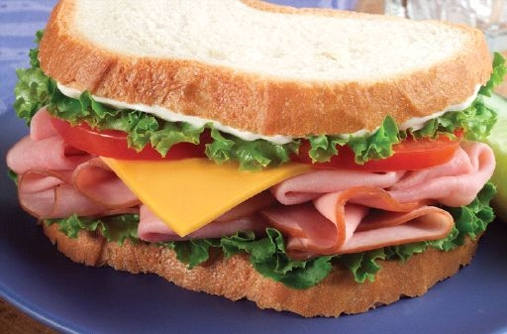NATATS CANTEEN MENU 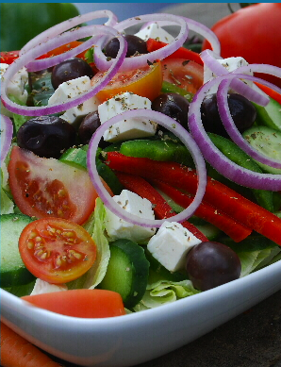
2024

E= Everyday O= Occasional V= Vegetarian H= Halal

Tiger sandwiches  E-VH: Veg/jam/che spread $2.50  E- H: Egg $4.00  E- H: Egg & lettuce $4.50  E- H: Roast chicken $5.00  E- H: Chicken, let & mayo $6.00  O- Leg ham $5,00  O- Leg ham & cheese $5.50  O- Leg ham, cheese, tomato $6.00  boxes  V E- salad box $5.00  E- add chicken or ham or egg $6.00  Wraps  E-H: Roast chicken $5.00  E-H: Roast chicken, lett, mayo $6.50  E- Leg ham, cheese, tomato $5.50  V-E- Cheese, tomato $4.50  Burgers  E- Beef, cheese, sauce $5.00  O- Chicken breast, lett, mayo $5.00  O- Chicken breast, lett, peri sauce $5.50  O- Chicken & cheese $5.00  V-O vegetarian, lett, mayo $5.00 | Homemades  E-Beef lasagne $5.50  E-Beef spag bol $5.50  E-H: Chicken lasagne $5.50  E-H: Chicken spag bol $5.50  E-H: Butter chicken & rice $6.00  E- Nacho’s $5.00  E- mac & cheese $5.00  E- spaghetti & meatballs $5.50  Occasional foods  VH-(4) spring rolls $3.00  VH- ½ garlic bread $2.00  VH- full garlic bread $4.00  V- Cheese pizza $6.00  V-H-pizza wrap slab $6.00  (veg/chick/meat/ham & Pineapple/cheese)  H- (1) Chicken breast nugget $1.00  H- Chicken tender roll $3.00  H- Chicken tender wrap (lett, mayo) $6.00  H- Hotdog $4.50  H-Timber town sausage roll $4.50  H- Timber town pie $5.00  H- Mamme cup noodles $3.50 | Cool snacks  E- Piece fruit $1.50  E- Orange bag $1.50  E-Mixed fruit bag $2.00  E- Carrot bag $1.00  E- Egg bag $1.00  Snack attack  E- ½ popcorn $0.50  E- Full popcorn $1.00  O- Fruit snacks $1.00  O- LCM bar $1.00  O- mamme noodle snacks $1.00  O- CB balls or Cheese puffs $1.30  O- Pringles $1.30  O- Assorted chips $1.50  O- chicken jumpies $1.30  Our school canteen  Complies with the NSW  Healthy school canteen  Food & drink benchmarks | Drinks  E- Water $2.50  E- Poppers $2.00  E- Oak choc milk $3.00  E- Oak straw milk $3.00  E- Long life plain milk $1.50  E- With flavoured straw $2.50  E- Juice bomb $3.00  Ice blocks  E- Quelch stick $1.20  E- TNT snap $1.50  E- TNT mony $1.50  E- Juice cup $1.50  Lunch pack deals are available  From your canteen also from  Munch monitor on line ordering  www.munchmonitor.com

